**Using opencv in other examples and exercises**

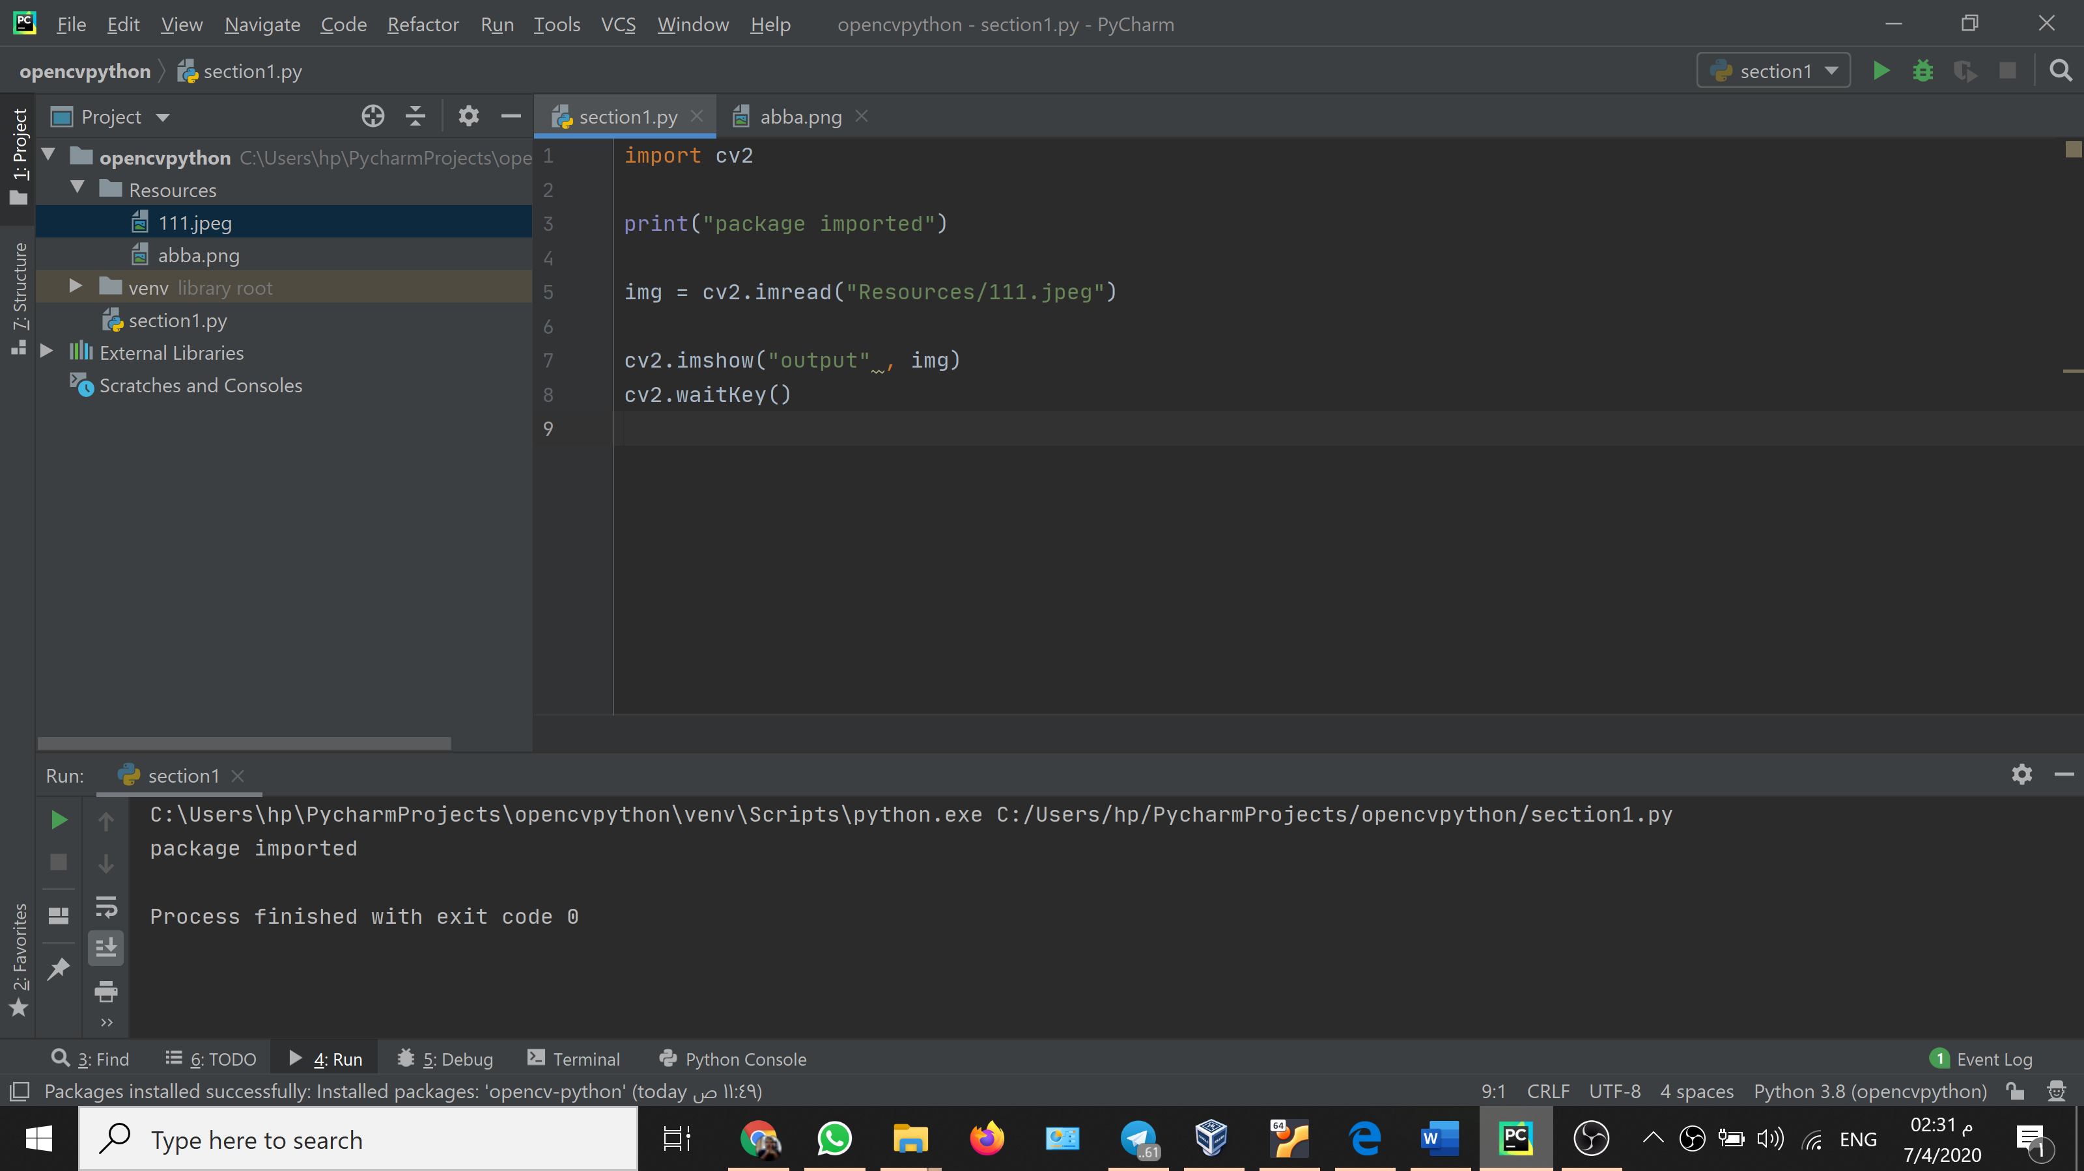

This code to call the image that we want from the path we selected

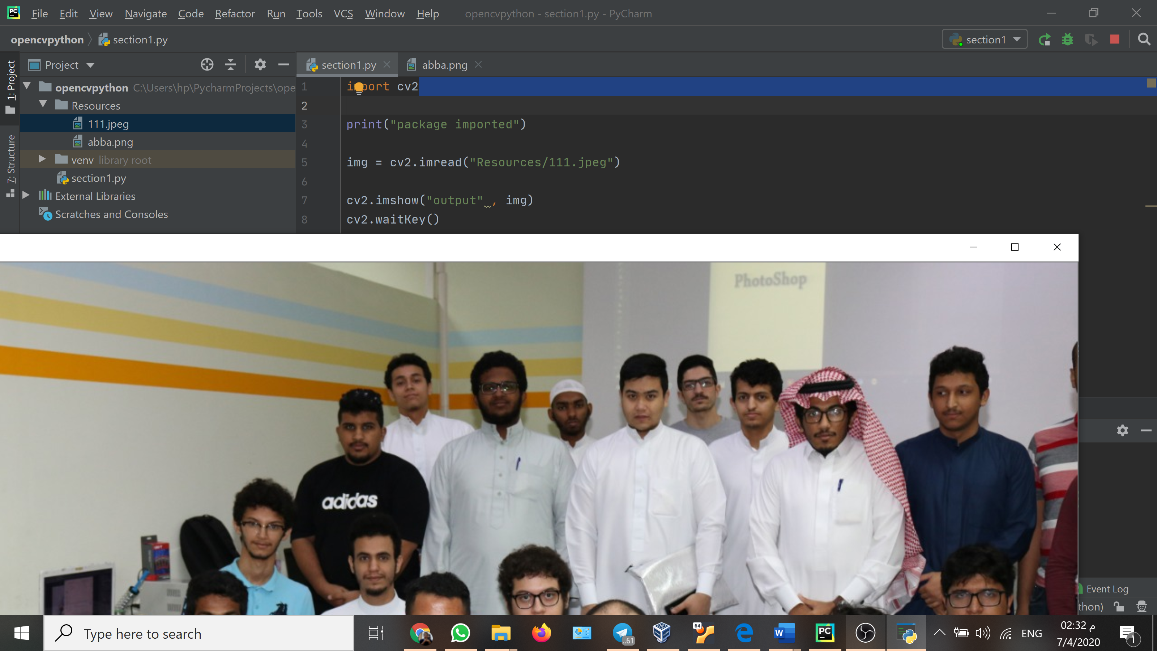

After we run the code, we get the image we selected

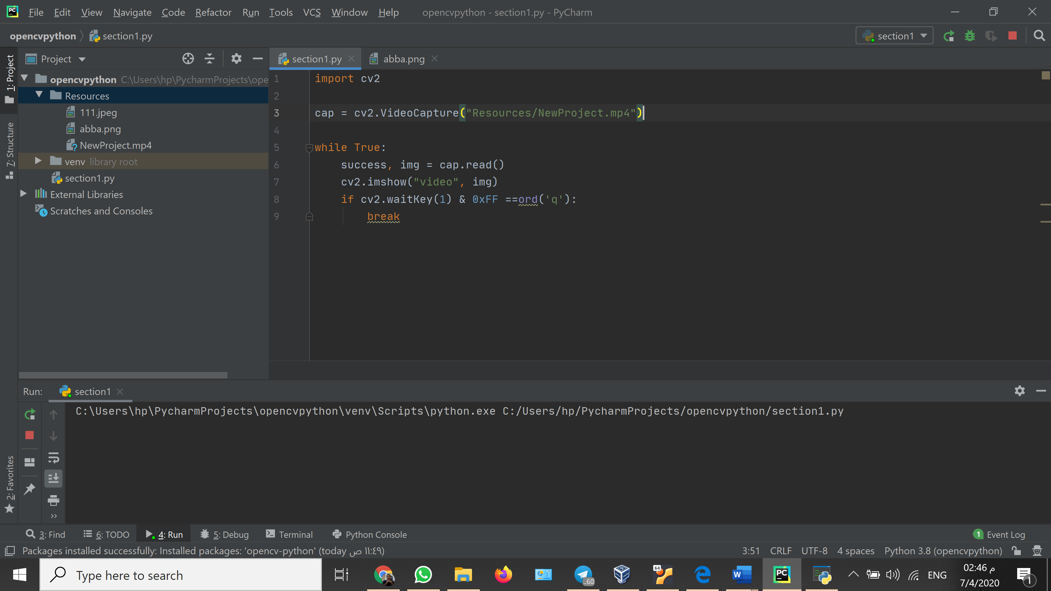

Here this code is to import a video that we select

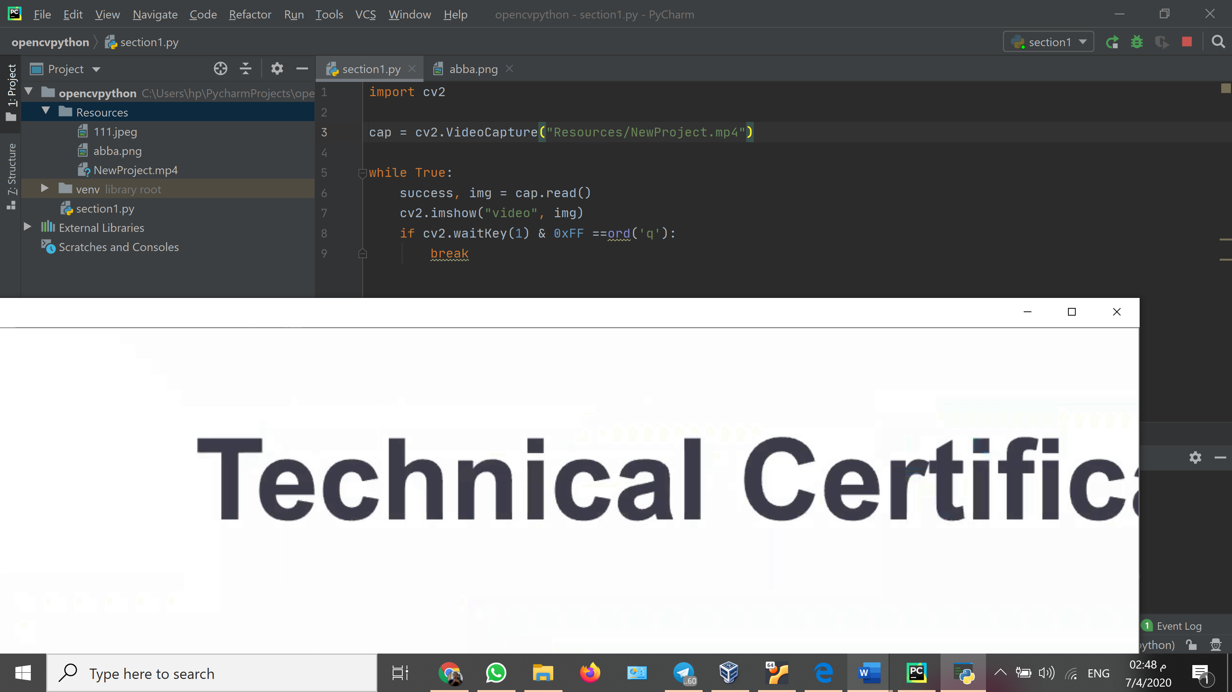

This the output of our code after we run it the video that we imported is working

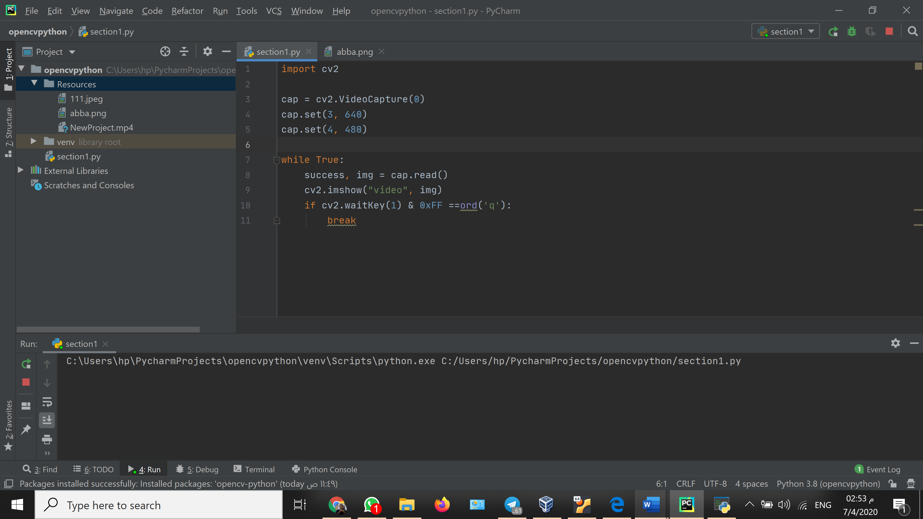

The same code that we imported the video with but we will change the resource we put to our id camera which by default is 0 if I have other camera, we can add their ids if we want to

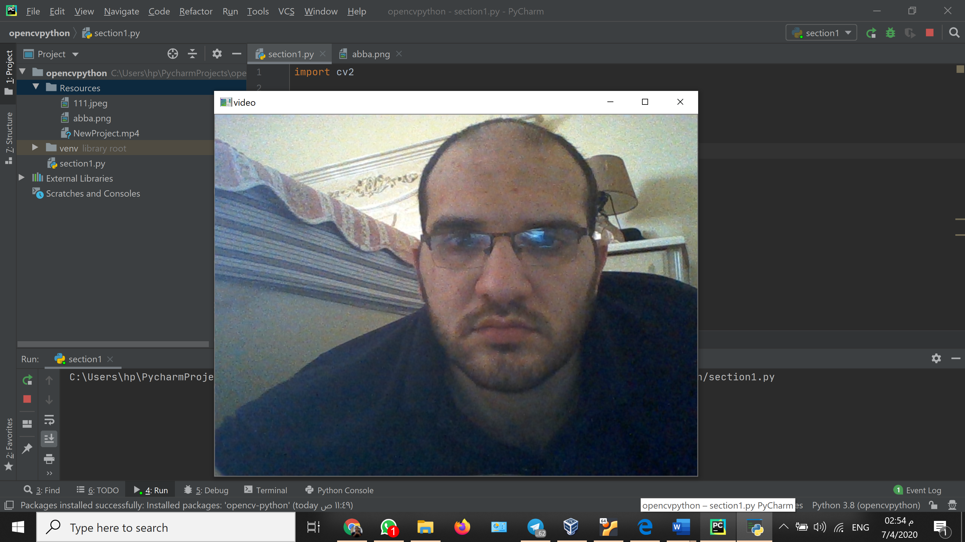

This the output of our code after we run it my webcam and I am there

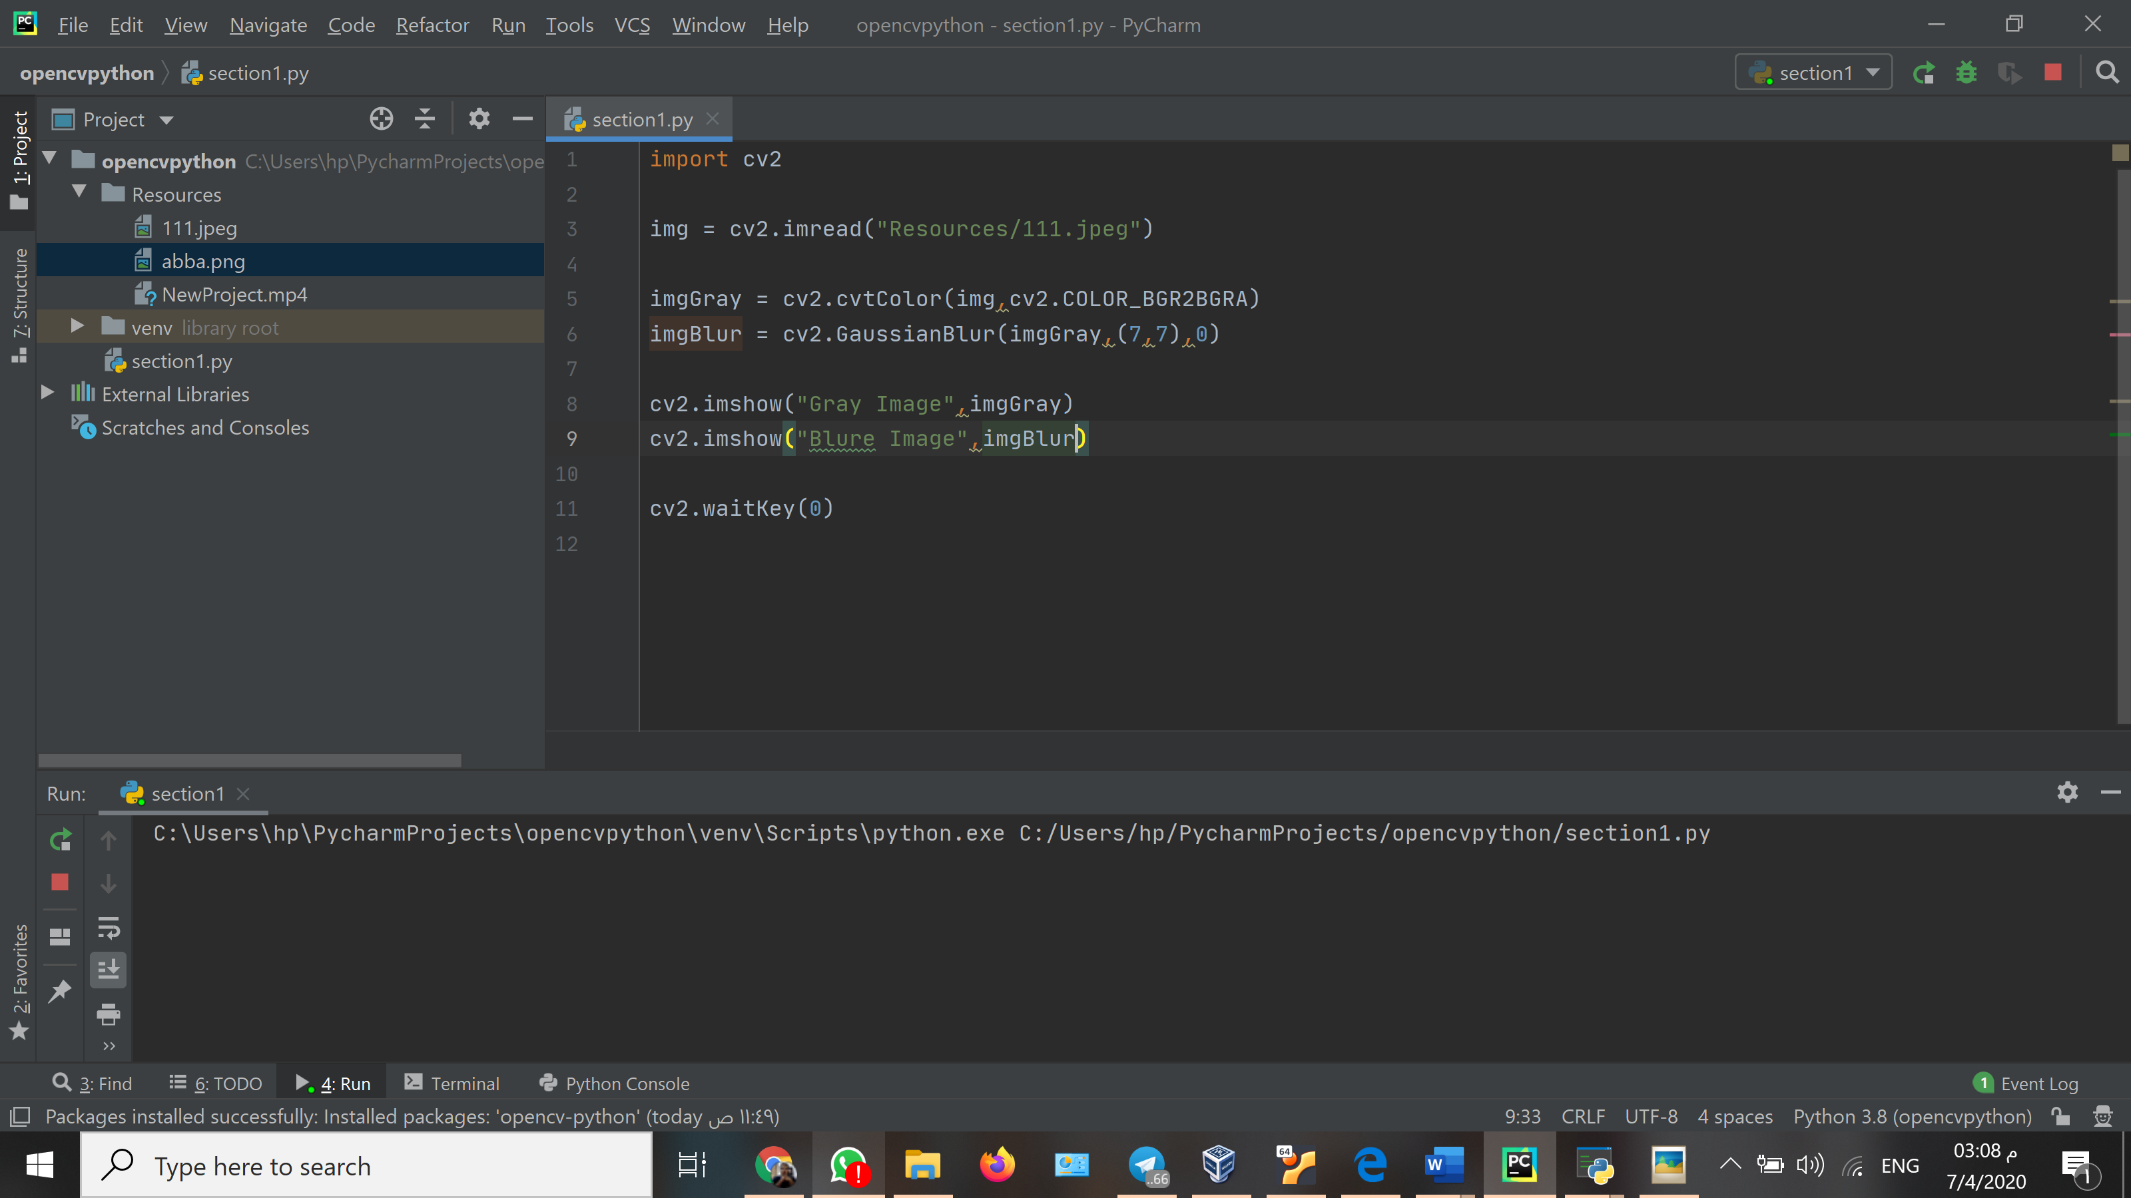

Here in this code we will add blur to our original image

After that we will compare it to see our output

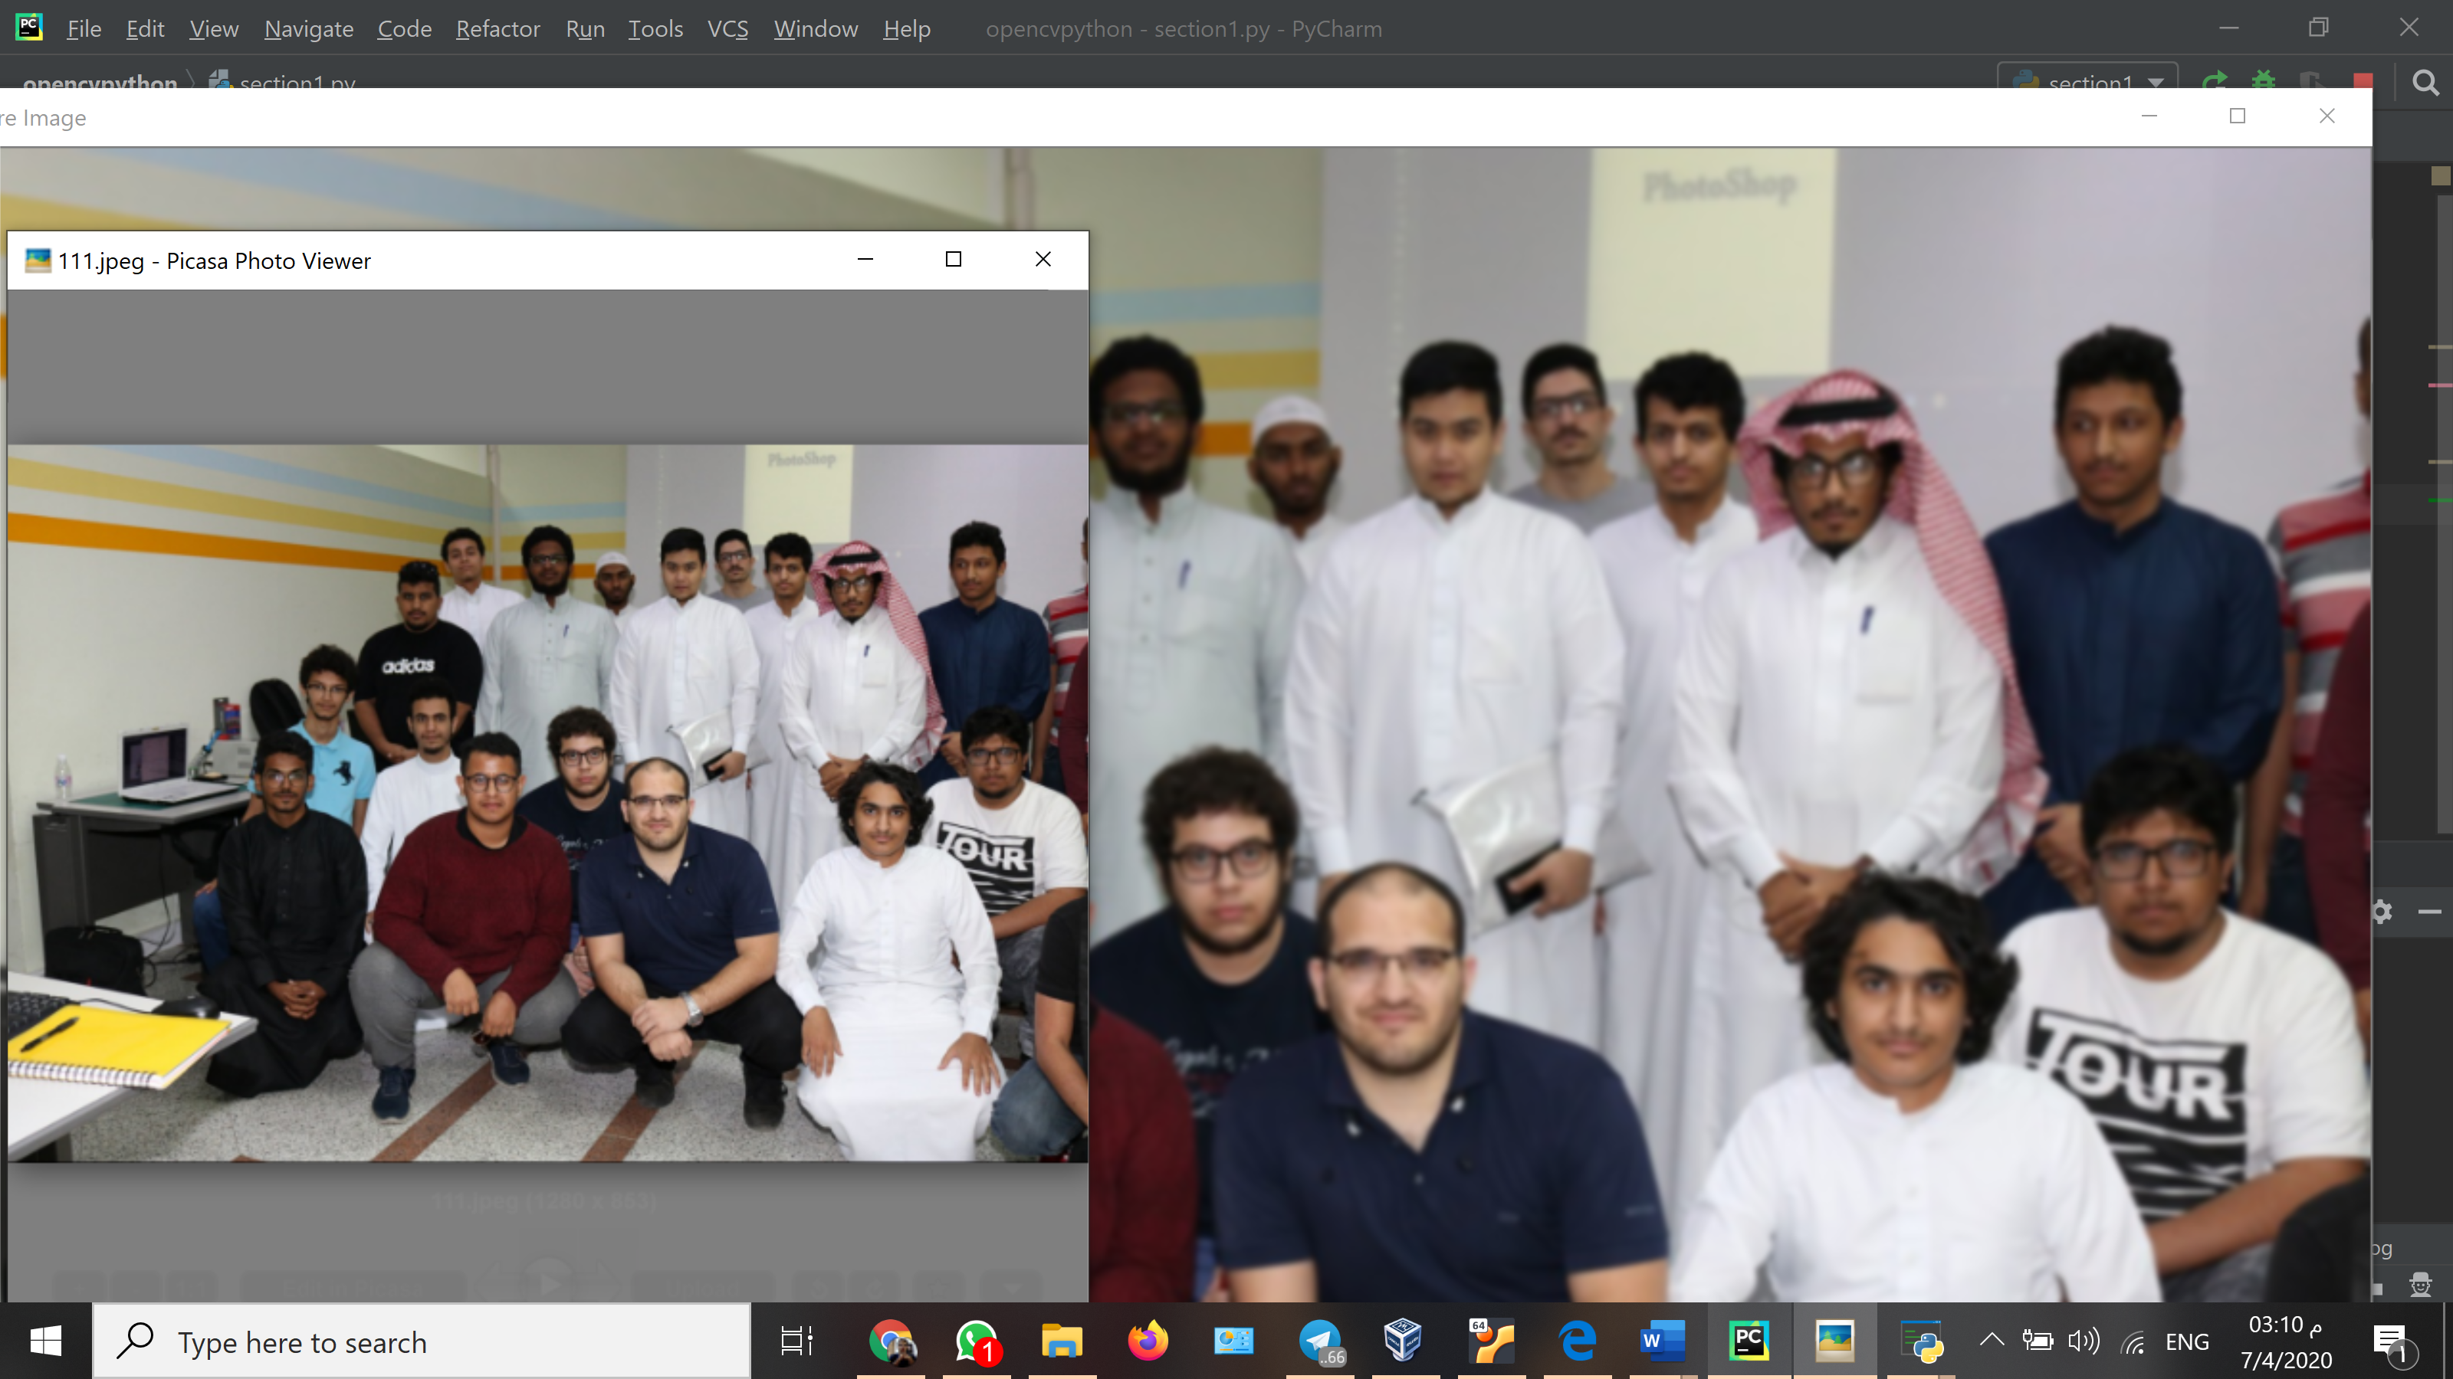

Here we can see the image with and without the blur effect

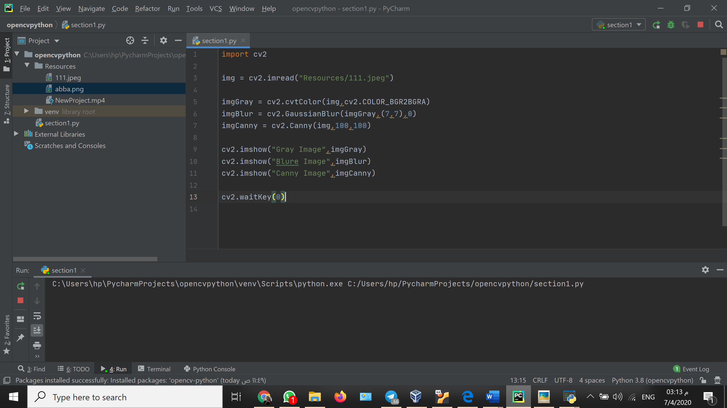

This code for the canny effect on the image

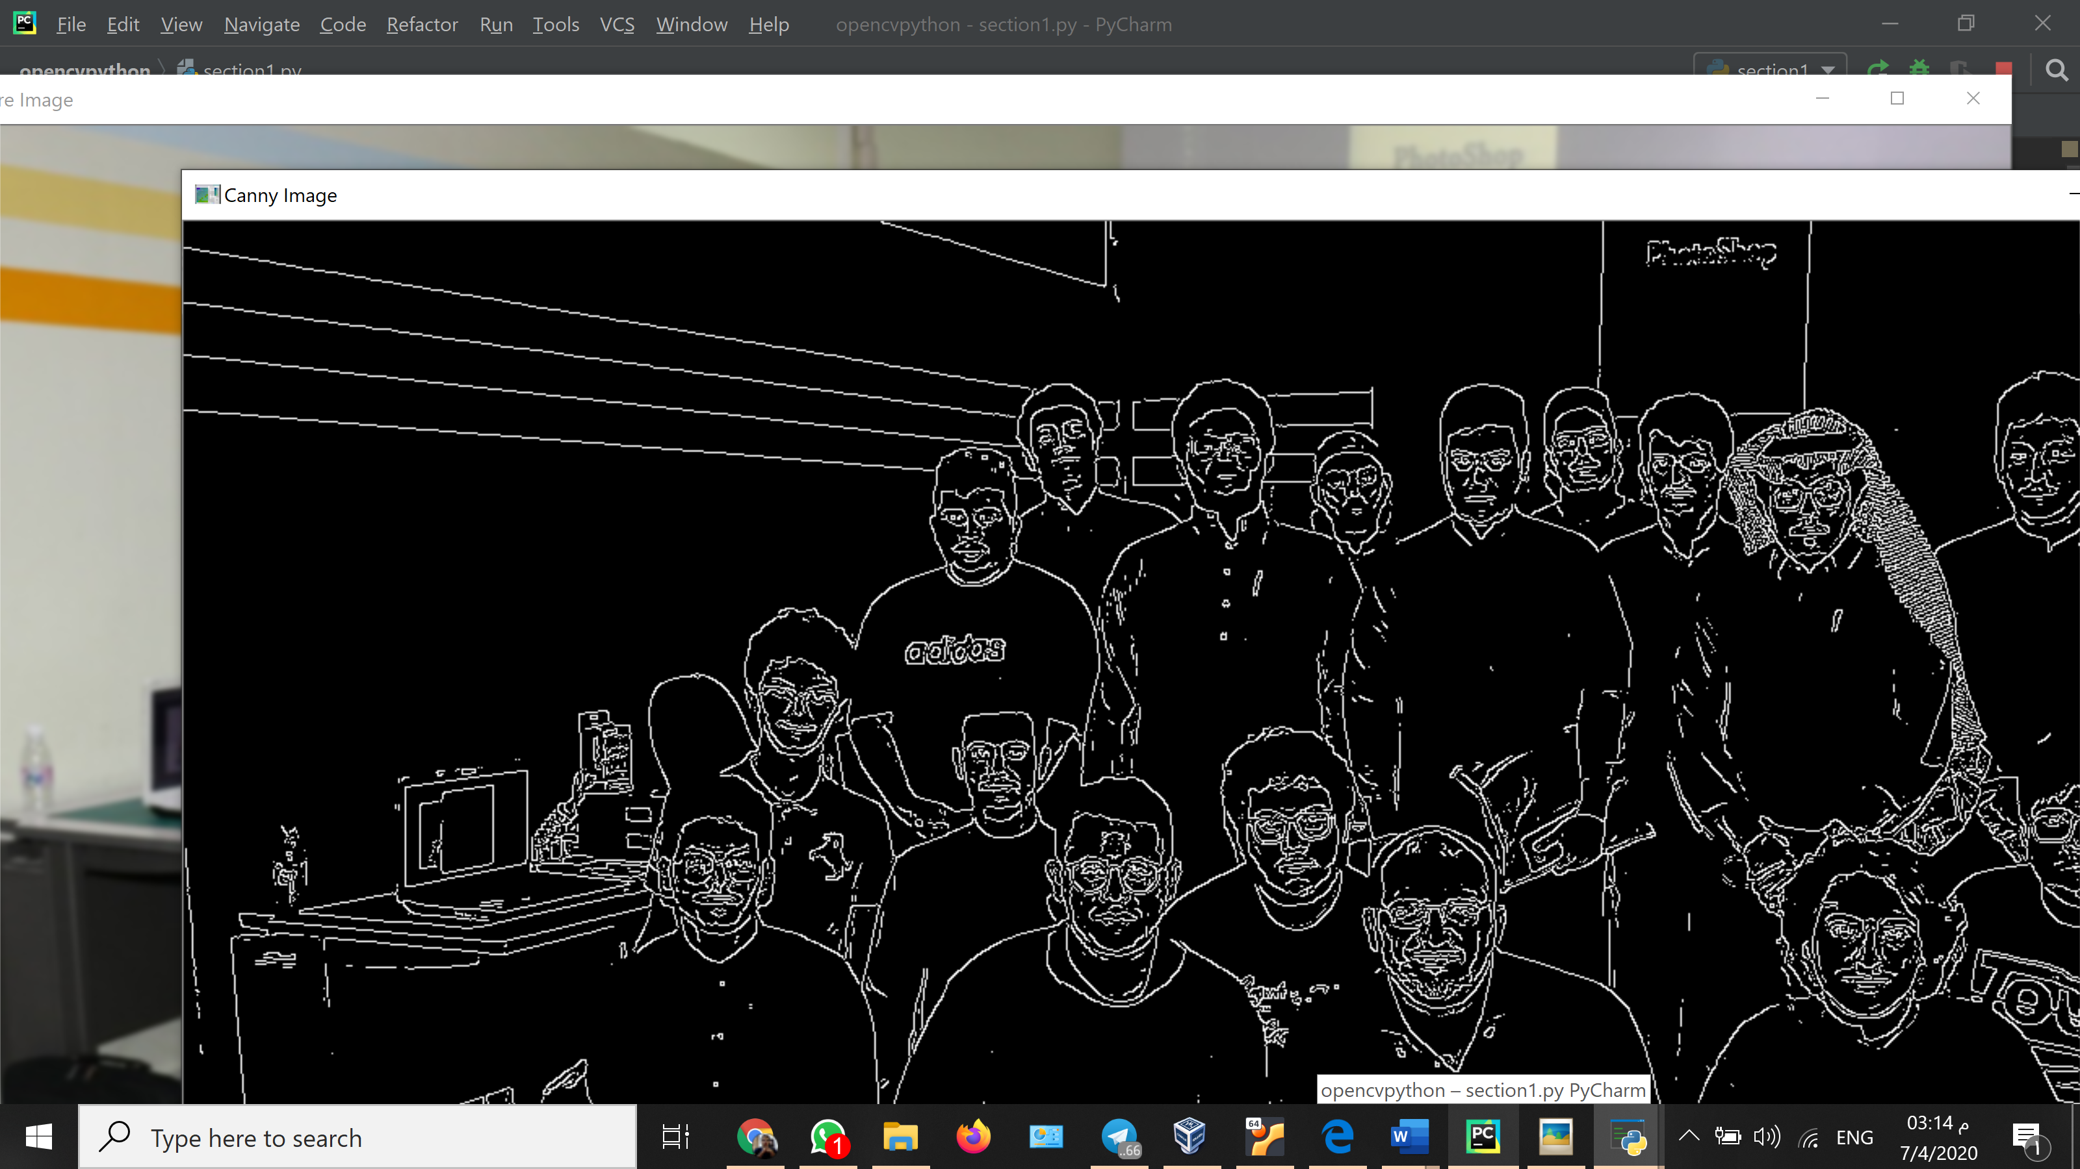here our output after we run our program with the canny effect added to it